Name: _______________________________ Date: _____________________

WEATHERING AND EROSION FACT SHEET

What is the rock cycle? The rock cycle is a group of changes in rock type. The main causes for these changes are (1) weathering and erosion, (2) melting and cooling, (3) heat and pressure and (4) compaction and cementation. All rocks can somehow change into one another.

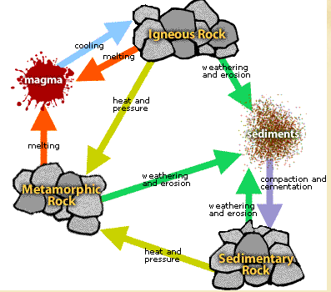

Igneous
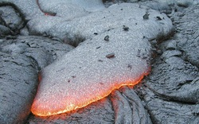

When magma cools, igneous rock is formed. This also creates crystals. Magma is basically lava before it actually comes out of a volcano and it is an extremely, hot liquidy substance that is made up of a lot of melted minerals. The process of cooling takes place underground and it occurs slowly. It can also occur above ground, where the magma cools quickly.

Metamorphic
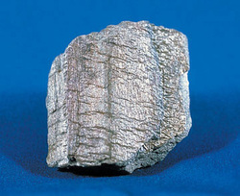

Metamorphic rocks are created when other rocks are transformed to another rock inside of the Earth from heat and pressure. Metamorphic rocks take millions of years to form. Some examples of rocks are marble, slate, schist, gneiss, and quartzite.

Sedimentary
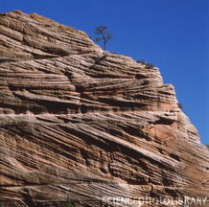

Sedimentary rock makes up about three-fourths (3/4th) of the Earth’s surface. They form at places like beaches, rivers, the ocean, and anywhere that sand, mud and other types of sediment collect. Slowly, the layer of sediment on the bottom of lakes, especially on the bottom of oceans grows deeper and deeper. The weight of all the sediment becomes immense, pushing down on lower layers of sediment with tremendous force. In addition, the number of minerals, which act like cement, bond the sediment together causing it to form sedimentary rock.

Weathering – Weathering is where rocks and minerals are broken down into smaller and smaller pieces. Extreme heat and cold, water and ice can all cause weather. Water wears away rocks, and can dissolve them. It does not involve the removal of rock material. There are three (3) types of weathering: physical, chemical and biological.

Erosion – Erosion is the transportation of weathered, or broken down materials. Wind and water can erode materials, and so can movements of the Earth. Water can carry the broken down rocks and so can wind. A landslide is when lots of materials are carried down a steep hill by gravity. A mudslide is when water makes the side of a hill heavy, and carries it downward. They are both examples of erosion.

How is Erosion different from Weathering?
Erosion involves the removal of solid material by a transporting (moving) agent. Weathering is the breakdown of rock into fragments at the Earth’s surface. No movement is involved in weathering.

Heat and Pressure - The atoms in rocks rearrange to form bigger and heavier minerals. The combination of heat and pressure may cause minerals in the rock to split into layers. Metamorphic rocks begin changing at temperatures of 100º Celsius to 800º Celsius. If you squeeze and heat a rock for a few million years, it can turn into a new kind of rock.

The pressure comes from layers of rock piling on top of each other, and the heat comes from magma. It’s like putting blankets on yourself – the more layers you put on, or the more blankets you put on, the more pressure you receive because of all the weight of the layers on top of you.

Compaction – is the process in which sediment is squeezed and in which the size of the sediment grains is reduced by the weight and pressure of the overlying (those lying on top) layers.

Cementation – is the process in which sediments are glued together by minerals that are deposited in water.

Cooling and Crystallization – Igneous rocks are the result of cooling and crystallizing magma. Igneous crystals are formed when freely moving atoms in melted rock become arranged in orderly patterns as they cool. As melted rock cools, the heat energy that allows atoms to move past one another decreases, and the natural attraction between atoms causes them to stick together with similar atoms in a crystalline structure. This process takes a long time to grow big enough to be seen.

Melting – When rocks reach extreme temperatures, they begin to melt forming magma. Magma is a molten rock made from other melted rock.

Refer to the Geological Society – The Rock Cycle Processes for more information:

https://www.geolsoc.org.uk/ks3/gsl/education/resources/rockcycle/page3446.html

