KEY MATHEMATICAL TERMS
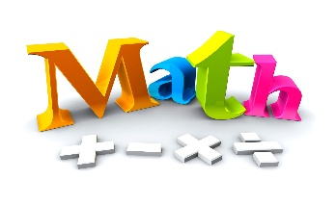

- Algorithm – a step-by-step solution to a math problem.

- Decimal fraction – a fraction where the denominator (bottom number) is a power of ten (such as 10, 100, 1000) e.g., $\frac{53}{100}$ = 0.53 or $\frac{51}{1000}$ = 0.051

- Denominator – the bottom number in a fraction.

- Division – it is the splitting into equal parts or groups.

- Multiplicative Inverse – same as the reciprocal.

- Numerator – the top number in a fraction.

- Reciprocal – the reciprocal of a number is 1 divided by the number, e.g., for the number 8 its reciprocal is: 8 x $\frac{1}{8}$ = 1

